CS550 Project #2  
Xiaoru Chen  
Email: chenxia2@oregonstate.edu

A Screen shot from my program: 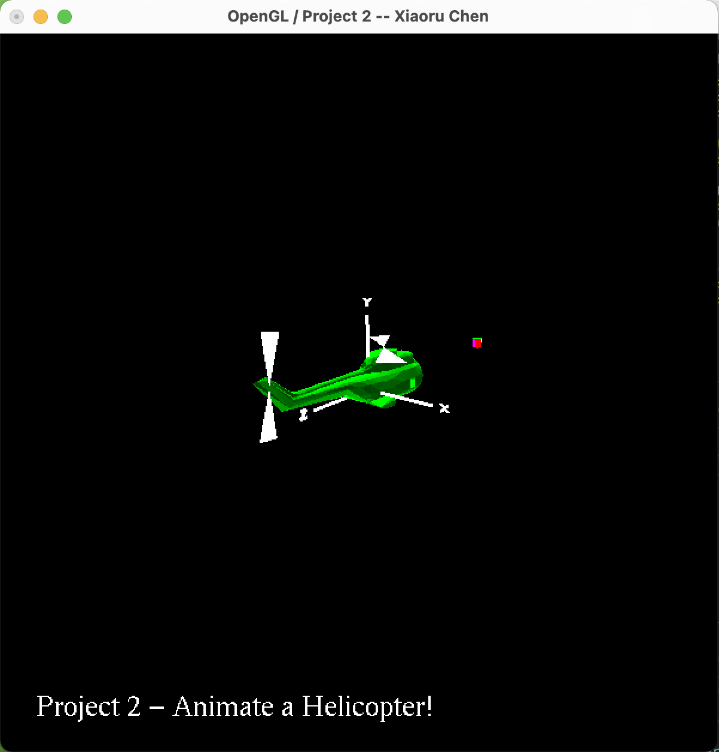

The link to the Kaltura video:

<https://media.oregonstate.edu/media/t/1_unugp3vz>